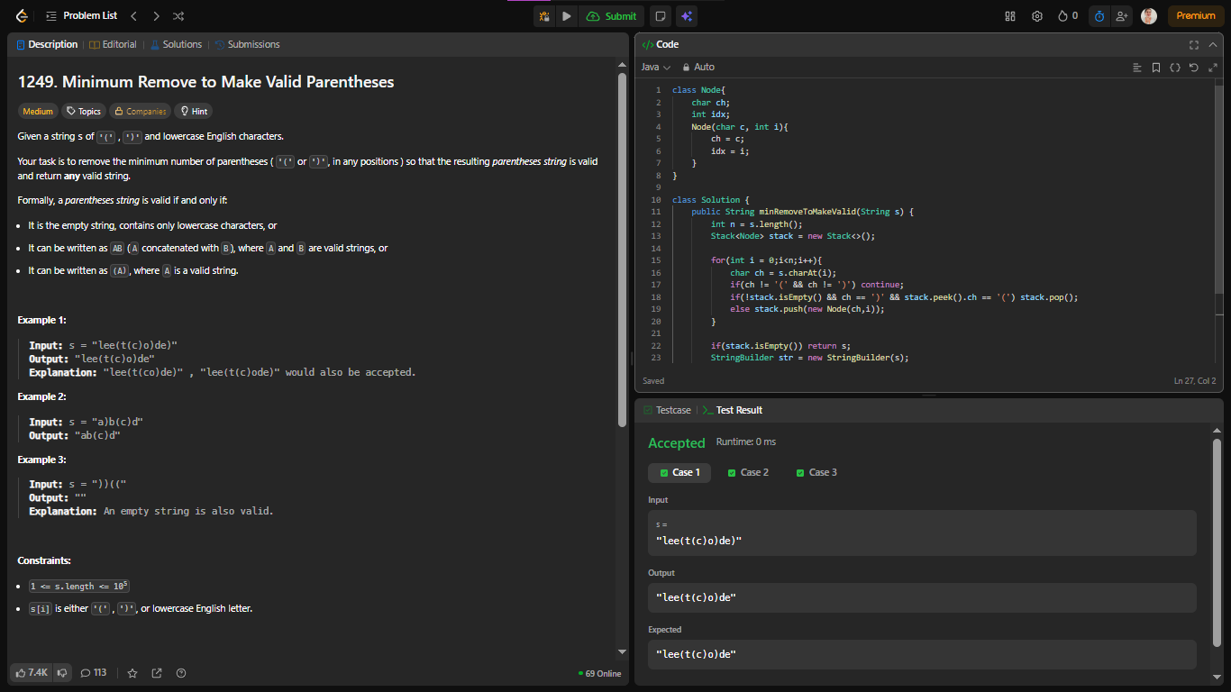
class Node{
char ch;
int idx;
Node(char c, int i){
ch = c;
idx = i;
}
}
class Solution {
public String minRemoveToMakeValid(String s) {
int n = s.length();
Stack<Node> stack = new Stack<>();

for(int i = 0;i<n;i++){
char ch = s.charAt(i);
if(ch != '(' && ch != ')') continue;
if(!stack.isEmpty() && ch == ')' && stack.peek().ch == '(') stack.pop();
else stack.push(new Node(ch,i));
}
if(stack.isEmpty()) return s;
StringBuilder str = new StringBuilder(s);
while(!stack.isEmpty()) str.deleteCharAt(stack.pop().idx);
return new String(str);
}
}

